Term 1 Week 4

Dear St Joseph’s families
As we enter into the second week of Lent, we are reminded of our simple humanity. The phrase, “only human” refers to the fact that no one is perfect….and neither should we be. Life is about navigating the challenges and appreciating the simple moments of joy. When we acknowledge our “humanness”, own our flaws and work towards change, we are becoming more like the person that God calls us to be.
When I speak with our children, I remind them of the many mistakes I make every day, but that with each mistake, comes a wonderful opportunity to learn. Often the best learning we ever do is through the challenges we face. It is ok to fail…to learn from each set back and to be better for it.
Very soon, some of our children will be joining with others in the Parish to celebrate the Sacrament of Reconciliation. We ask that you keep them, and their families in your prayers as they prepare to take this next step in their Faith journey. You are very welcome to join them at 5:30 pm on Tuesday, March 5th at St Laurence’s Church, Leongatha.
It has been great to hear about the conversations you have been having with your children’s teachers. We are grateful for the time you made to invest in your children’s education.
This week I have been thinking about our children and their need for strong boundaries, particularly as they navigate new environments and experiences. Children who are well prepared, who understand what they can and can’t do and who are clear about the expectations are less anxious. This is because they don’t have to spend precious cognitive energy wondering what might happen, or how they are supposed to be. So…it is ok to say “no” to children and it is ok to share with them the secrets of how to behave. When we do that, consistently and in a loving, gentle way, we are helping them to explore their world safely and with confidence.
On behalf of the staff here at school, I thank you for your ongoing support.
Sharon

Sports – District Swimming

St Joe’s had a great day at the District Swimming at Korumburra Pool.

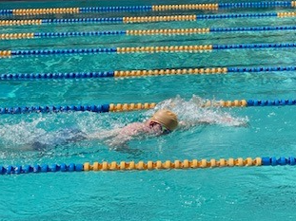

Our boys represented us beautifully; they stepped out of their comfort zones and gave it their all.

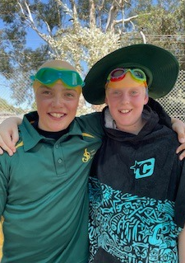

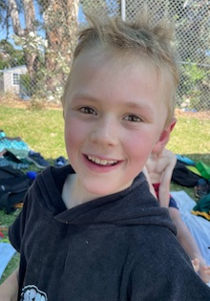

Special thanks to Lachie’s mum, Sarah who braved the sun and time kept all day and to the parents who came along to cheer us on.

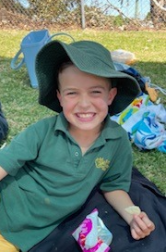

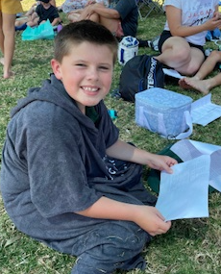

Good luck to Blake who wom his way through to the next level with a blue ribbon in the 50 metre breaststroke!

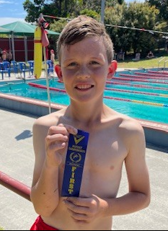

A call to all St Joey’s families to join in a parish celebration of the Feast Day of Saint Joseph.
In the month of March, we celebrate Saint Joseph’s Feast Day. St Joseph is our school’s patron saint. This year we will join with our fellow parishioners to celebrate St Joseph’s Feast Day on Sunday, March 17. We invite all families to attend the 9:30 am Sunday Mass to celebrate Saint Joseph who teaches us to be obedient to God’s will, hardworking and humble, and to love our families unconditionally. Following mass, you are invited to join the parish in a picnic morning tea. Please bring a plate to share.
Students are invited to be involved in the Mass by bringing up the Offertory gifts or reading a prayer or bible reading. Please RSVP Catherine Riseley - criseley@sjkorumburra.catholic.edu.au so we are able to allocate these mass roles to the children who will be attending.
Prayer to Saint Joseph
Dear God,
Thank you for Saint Joseph
who loved and cared for Mary and Jesus. He showed us how to listen to God, to work hard and to protect those we love. Please help us to be like him - loving, faithful, hardworking and full of courage.
St. Joseph, pray with us.
Amen.

Well Being – Friendship and Belonging

As the children really settle into life at school for 2024, we’d like to make you aware of our school’s SchoolTV page. This page is a fabulous resource for all kinds of advice about raising children. Each fortnight we will give you the link to a topic which might be useful. The page has a series of short videos with advice from the experts. You’ll also find fact sheets, suggested books, apps, websites and much more. There is also some great content from organisations such as Beyond Blue, ReachOut, HeadSpace and others.

This week we are focussing on Friendship and Belonging. It is not always easy for children to always know how to manage friendships. Learning how to make new friends and keep them involves a number of skills every young person needs to understand and develop. For some these skills will come very naturally, allowing them to easily move between different friendship groups, sharing their experiences and opening up to new people. For others, this can be much harder to navigate. Belonging to a group that is like-minded with similar interests is highly beneficial to a child’s wellbeing. Friendships are full of ups and downs and it is better for kids to learn how to manage and build their own friendships, even though as an adult carer you may be tempted to interfere.

Here is the link to some great advice. https://sjkorumburra.catholic.schooltv.me/newsletter/friendship-belonging

Home Learning Connection
Play games together that suit your child’s age eg: Scrabble, UNO, Snakes and Ladders, Connect 4, Memory etc. --this encourages talk as well as thinking strategically and following instructions

Fundraising for our Veggie Garden

Our school Vegetable garden is being revitalised and we hope to have seasonal produce that can be used in cooking activities.
We would like to raise money for the purchase of seedlings, fertiliser and tools and plan to do this through collecting donations of eligible plastic, metal and tetra drink containers.
Many of you will already be making use of the Vic Container Deposit Scheme to recycle your cans and bottles. 10c for each eligible container- the 10c is usually marked near the barcode.
We will be collecting only plastic, cans and tetra containers. If you can spare even 1 or 2 containers and send them to school that would be great. There will be a designated bin near the other school bins on the Bridge St side of the school.
Eligible containers look like this:

Our senior student leaders will be selling “Zooper Doopers” at lunchtime each Friday during Term 1. If your child would like to buy one, please send them to school with a gold coin. Sugar free Zooper Doopers are also available. The money raised is being used to improve our outdoor areas.

World’s Greatest Shave
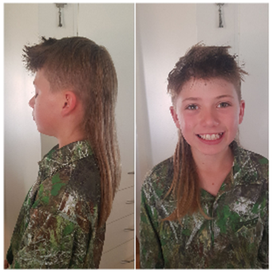
Hello Families
Blood cancer is Australia's hidden cancer crisis. There are 140,000 families facing blood cancer right now. Every day, 53 Aussies are diagnosed with blood cancer and it takes the lives of 16 Australians every day.
These numbers are set to double by 2035. Unless we do something about it. That's why we've signed up for the World's Greatest Shave.
We're raising funds for the Leukaemia Foundation to give Australians facing blood cancer life-changing practical and emotional support. And to fund critical research, bringing us closer to the day when zero lives are lost to blood cancer.
Will you be part of our World's Greatest Shave community and donate to my page?
Your donation means that together, we're working to stop blood cancer in its tracks
We can't delay taking action together.
That's why Oscar Olsen and Team have decided to take part in the Leukaemia Foundation's World's Greatest Shave. (So Far we have Joe Tripodi and more Welcome.) Oscar will also be donating his hair. So Jump onto Team OOO or please support in any amount small or big will make a real, tangible difference.
I'll be raising crucial funds that will give people facing blood cancer all the support and information they need, while driving breakthrough research projects discovering better ways to diagnose and treat blood cancer.
You have the power to help me make an extraordinary difference.
Date will Be Wednesday 27th March at School. More information to follow.
Will you help by sponsoring me?
Simply click here:
http://my.leukaemiafoundation.org.au/oscarolsen
https://secure.leukaemiafoundation.org.au/registrant/TeamFundraisingPage.aspx?TeamID=144424
We will also have a Donation/Fundraiser Box at the Office.
Thank You!
Oscar Olsen
Oscars QR Code
Art Photos
Gr5/6s create charcoal drawings exploring how symbols may be used in their interpretation of pets body structure and investigating different artistic concepts such as monotone colour, lightening tints and darkening shades.
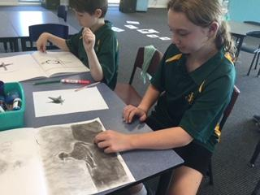A whippet by Mia
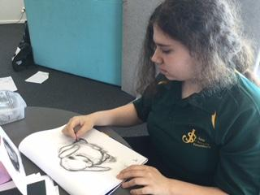
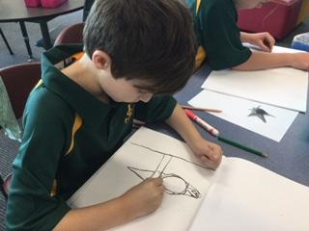
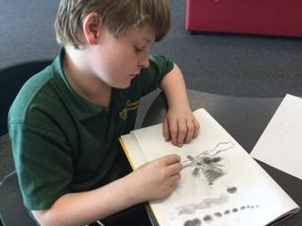
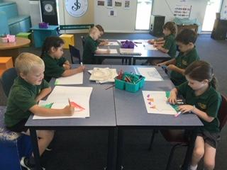
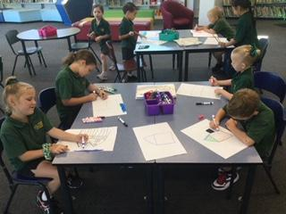
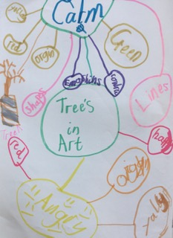
ART MIND MAP by Arden
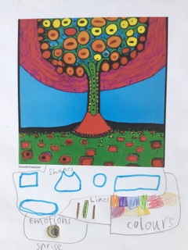
Public Notices

DATES TO REMEMBER
Wed, 28th February | Foundation Rest Day
Thurs, 29th February | Science Circus Incursion | All Years
Fri, 1st March | School Assembly | All Welcome
Tues, 5 March | Reconciliation | 5.30 pm at St Laurence’s Church
Wed, 6th March | Foundation Rest Day | Last One
Fri, 8th March | School Closure Day
Mon, 11th March | Public Holiday
12th March to 15th March (Tues to Fri) | Swimming Program | Our Grade 2-6 students will be participating in swimming lessons during Term 1 | Leongatha SPLASH
Fri, 15th March | School Assembly | All Welcome
19th March to 22nd March (Tues to Fri) | Swimming Program (as above) | Leongatha SPLASH
TERM DATES
Term 1 | Thurs, 28th March | Last Day of Term 1
Term 2 | Mon, 15th April | First Day of Term 2

